AWS ASG Task

- Create one VPC in N. Virginia region.
Create VPC in N. Virginia (us-east-1)
Steps:
- Go to VPC Console → Your VPCs → Create VPC
- Select VPC only
- Enter:
  - Name: ASN01
  - IPv4 CIDR: 172.31.0.0/16
- Click Create VPC
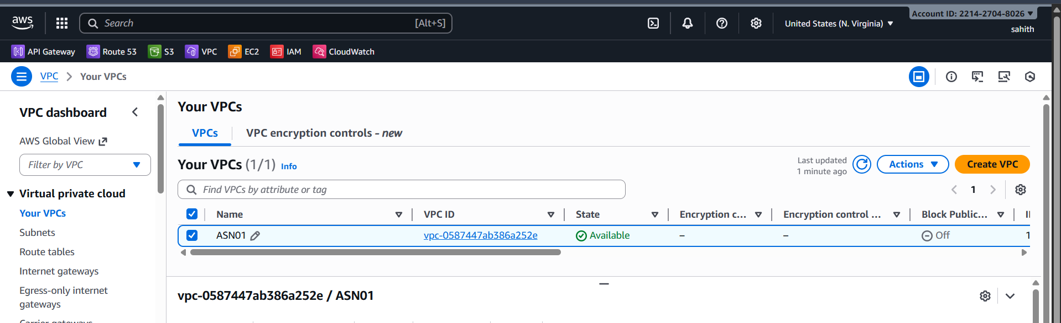

- Create two subnets: one public subnet and one private subnet.

Create Subnets
Public Subnet
- Go to Subnets → Create Subnet
- Select VPC: ASN01
- Add:
  - Name: public-subnet
  - AZ: us-east-1c
  - CIDR: 172.31.0.0/28
- Click Create Subnet
Private Subnet
- Name: private-subnet
- AZ: us-east-1c
- CIDR: 172.31.0.16/28
- Create subnet

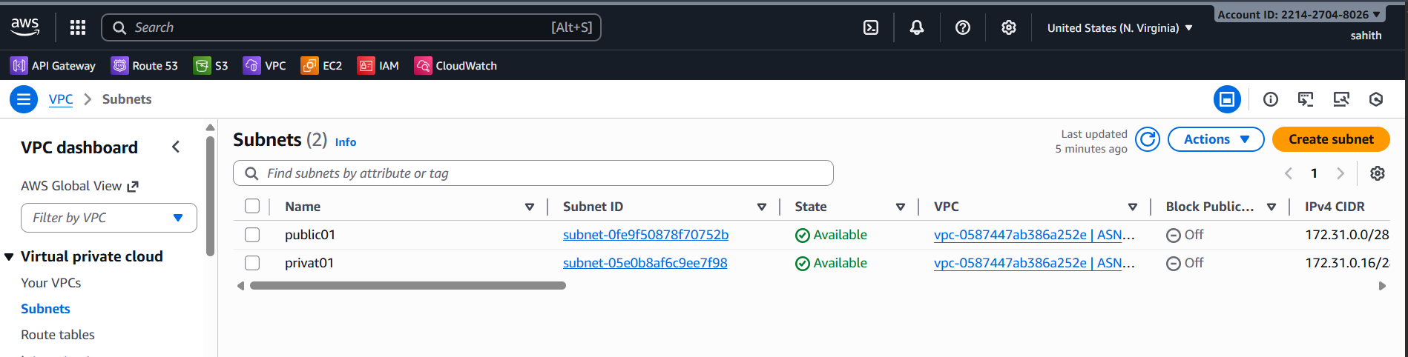
- Attach an IGW to the VPC.
Attach Internet Gateway (IGW)
- Go to Internet Gateways → Create IGW
- Name: IgwASN01
- Attach to ASN01
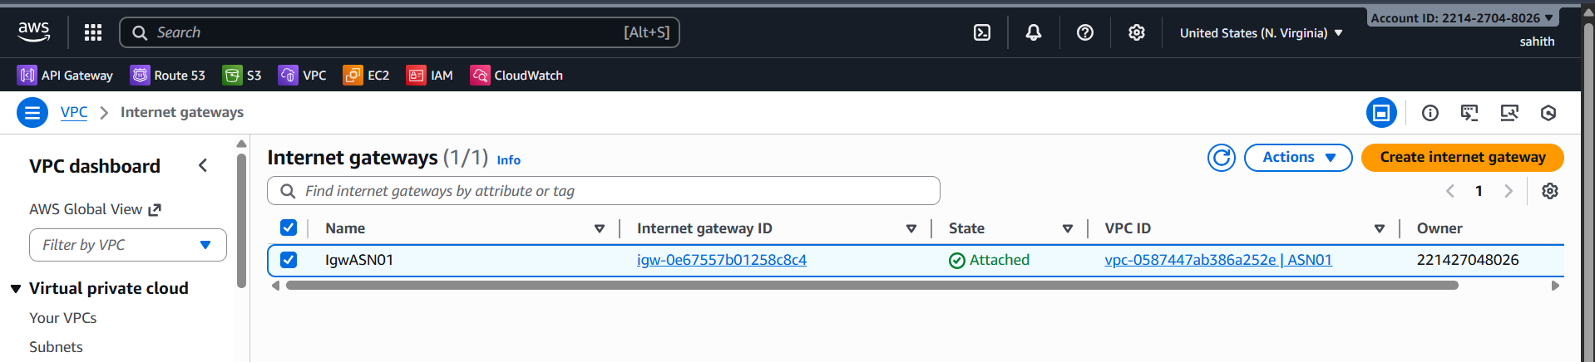
- Create one public route table (RT) and one private route table.
Create Route Tables
Public Route Table
- Go to Route Tables → Create Route Table
- Name: publicrt01
- VPC: ASN01
- Edit Routes → Add Route
  - Destination: 0.0.0.0/0
  - Target: IgwASN01
- Edit Subnet associations → select public-subnet
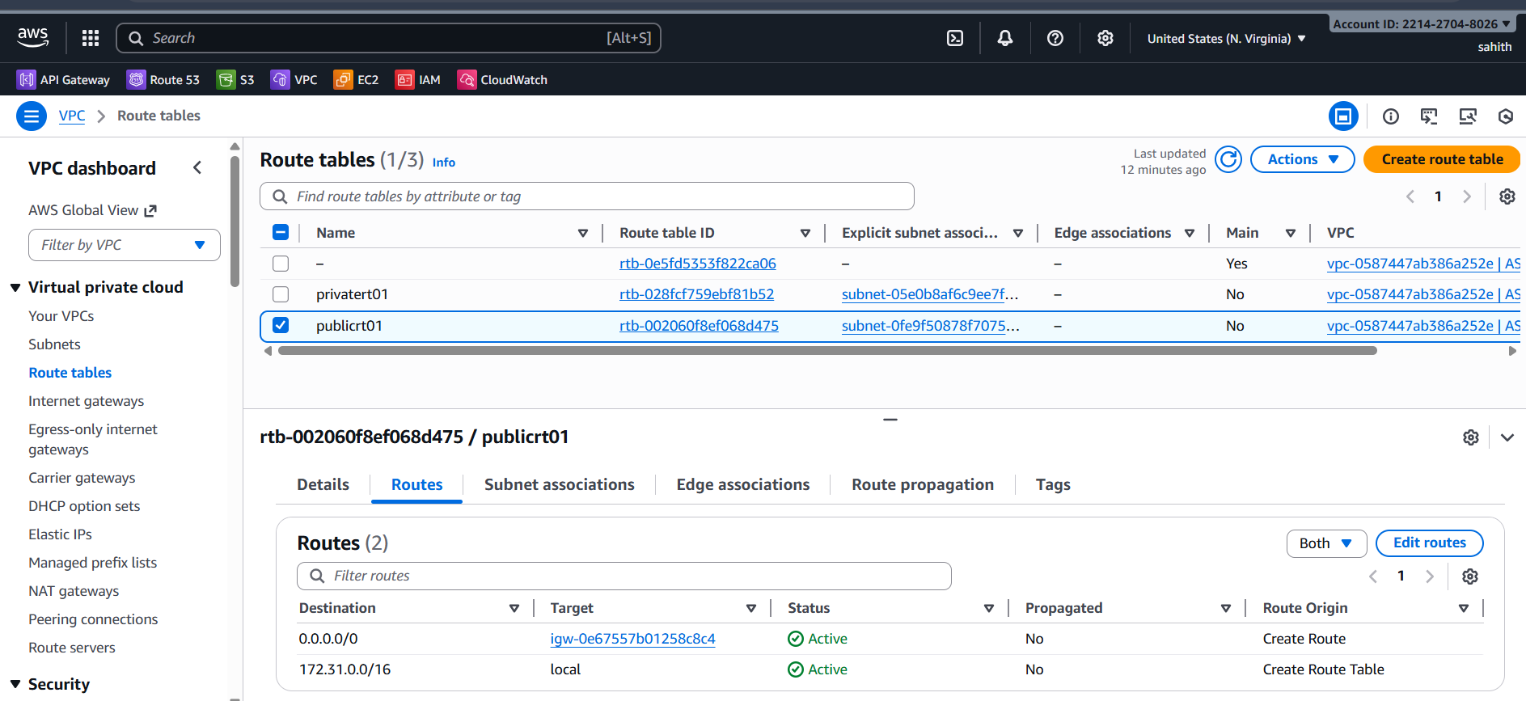
Private Route Table
- Name: privatert01
- VPC: AGN01
(We will add NAT route later)
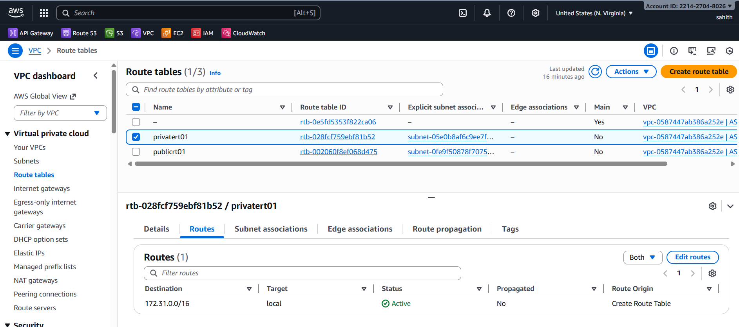

- Deploy a NAT gateway in the public subnet and attach the NAT gateway to the private subnet.
Deploy NAT Gateway in Public Subnet
- Go to NAT Gateways → Create NAT Gateway
- Subnet: public-subnet
- Allocate new Elastic IP
- Create
Attach NAT Gateway to Private Route Table
Edit private-rt → Routes → Add route
- Destination: 0.0.0.0/0
- Target: NAT Gateway
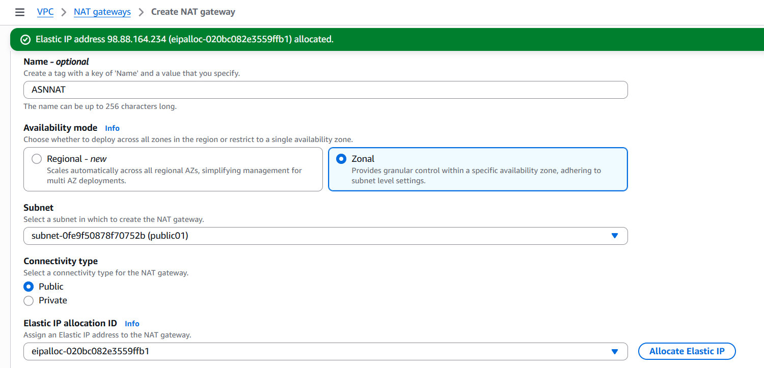
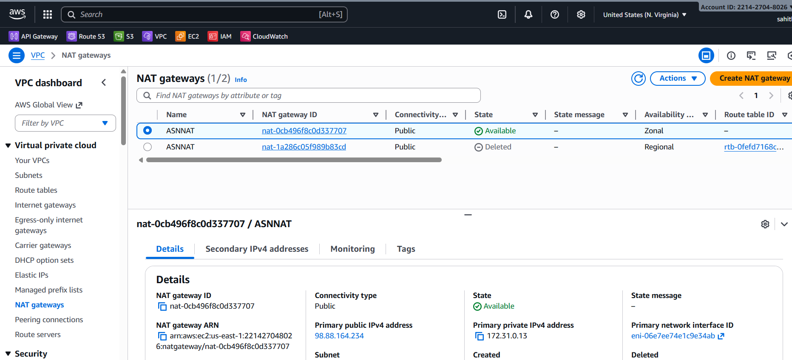
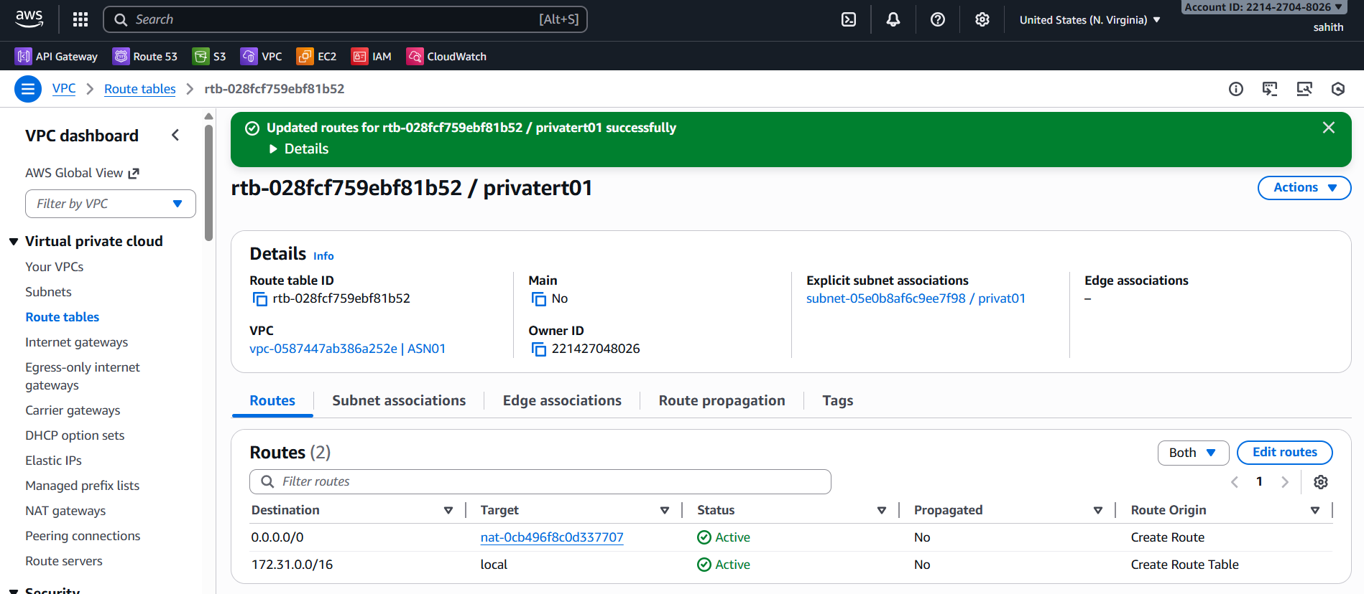

- Create two instances, one in the public subnet and one in the private subnet.
Create Two EC2 Instances
Public EC2 Instance
- Launch EC2 → Name: Ec2Public01
- Subnet: public-subnet
- Auto-assign public IP: Enable
- Security group allow:
  - SSH (22) My IP
  - HTTP (80) Anywhere
- Create instance
Private EC2 Instance
- Launch EC2 → Name: Ec2Private01
- Subnet: private-subnet
- Auto-assign public IP: Disable
- SG allow inbound port 80 from LB SG
- Create instance
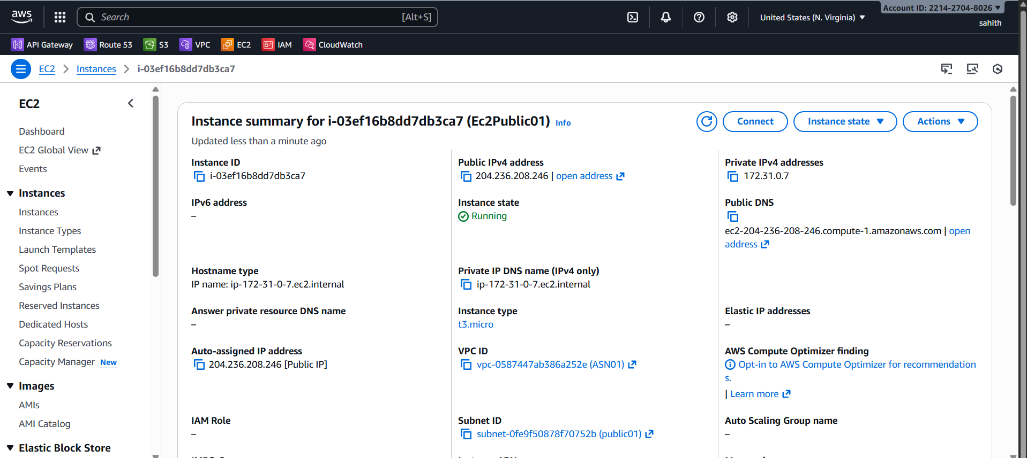
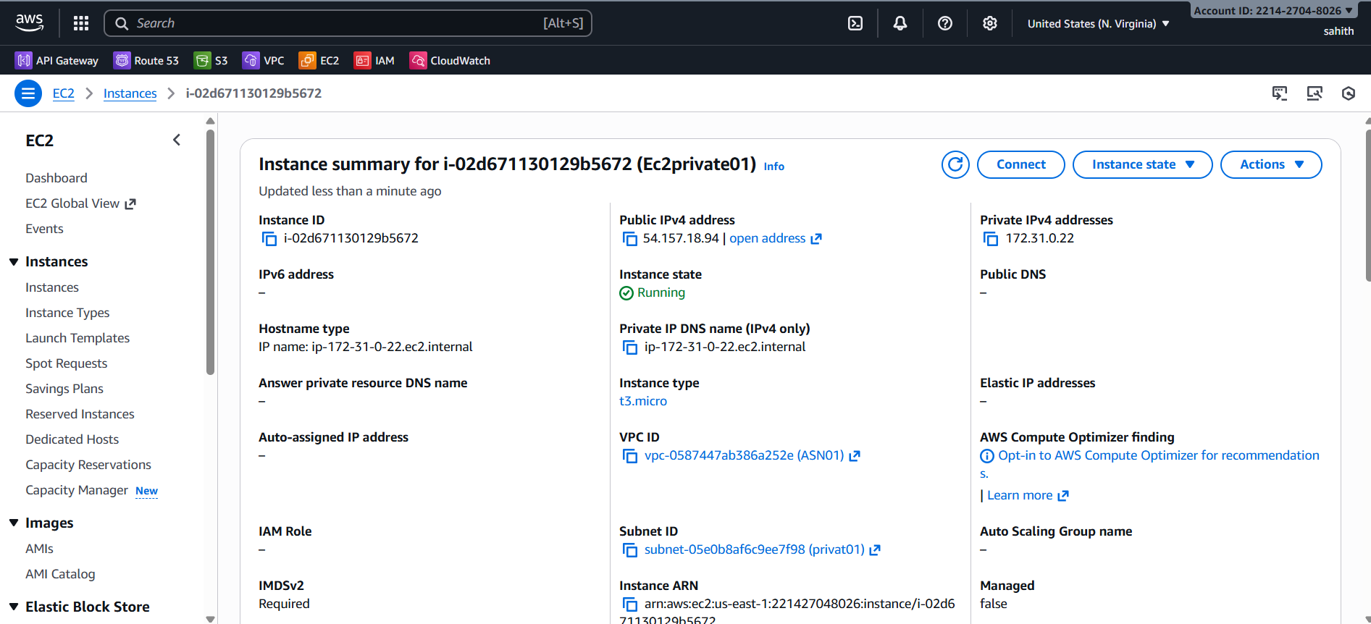

- Deploy Apache server on both EC2 instances with a sample index.html file.
sudo yum update -y
sudo yum install httpd -y
sudo systemctl start httpd
sudo systemctl enable httpd
/var/www/html/index.html

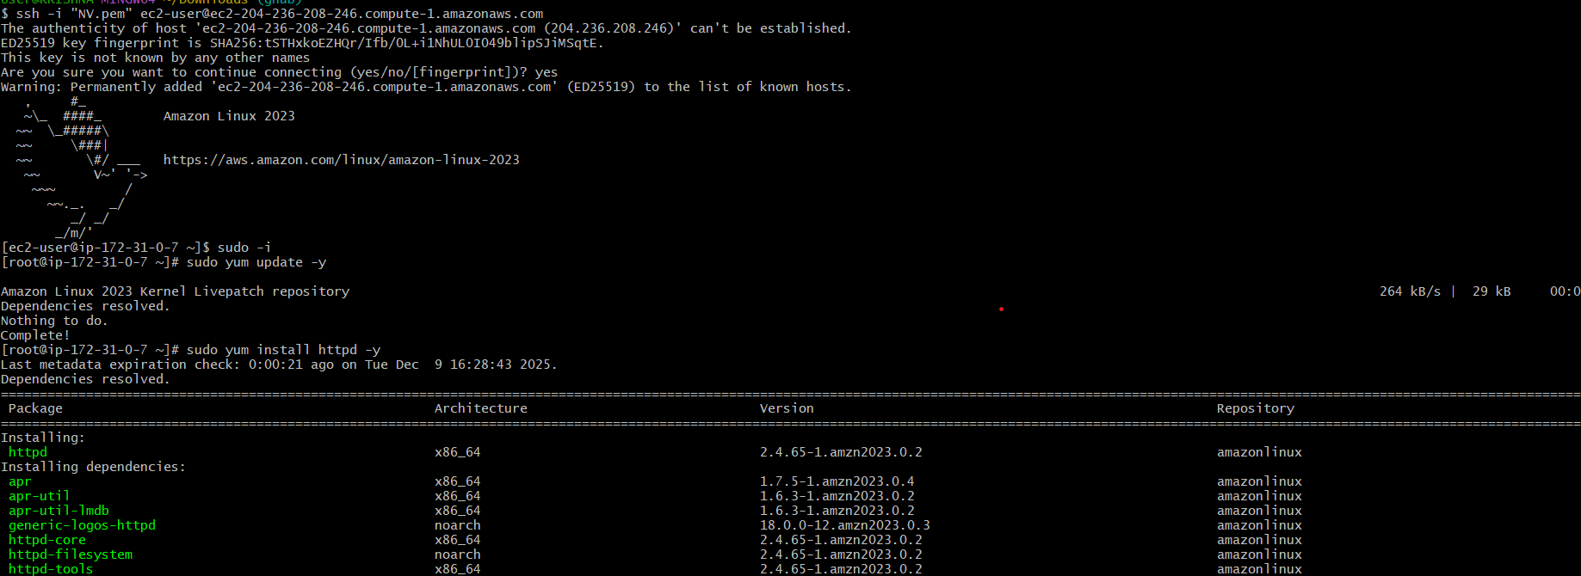
- Once installed start and enable service.
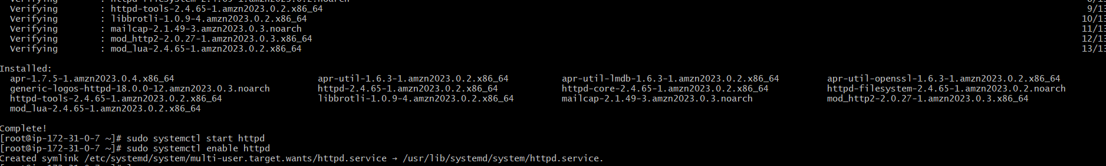
- Once everything is installed and running Use this command “cd /var/www/index.html/” to change directory and ls. We can see index.html below.
- Vi index.html (I have added shoppiex site index.html code here)
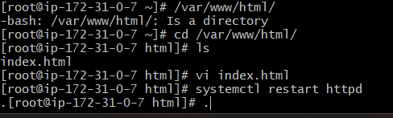
- Copy ec2 public01 public Id to browser search for it by adding port number 80 at the end.
- As we can below that website is visible.

- To connect to private ec 2 we use jump server and using private key which is in my local machine.
- Below is my pem key

- Now using vi created test.pem and pasted pem key here which we coped in before step.
- Gave permissions to it
- Using ssh -i test.pem ec2-user@ private Ip adress here
- Now we are sucessfully connected to private ec2.
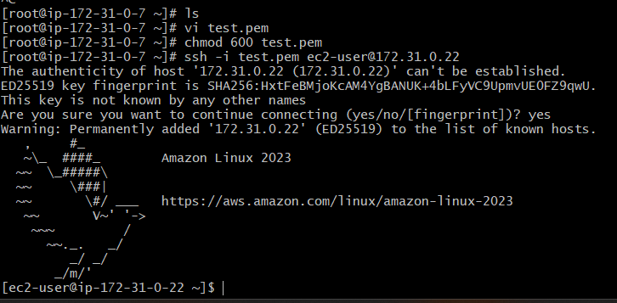
sudo yum update -y
sudo yum install httpd -y
sudo systemctl start httpd
sudo systemctl enable httpd
/var/www/html/index.html
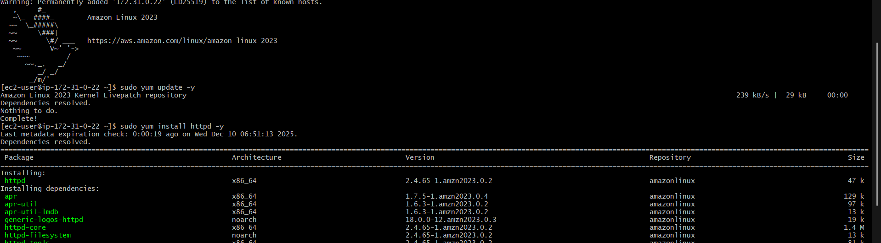
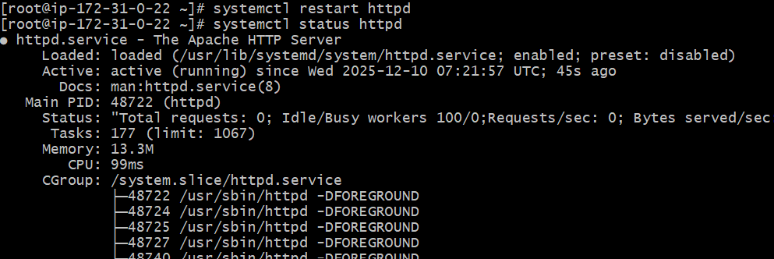
- After in installing httpd and editing index.html. to check the connectivity, we use curl. We are doing this because it is private ec2
- Use command” curl http://privateIP address: add port number at the end of Ip”
- As we can see below output it is connected.
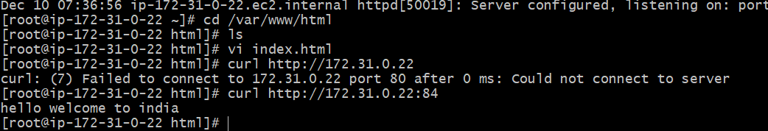

- Create one application load balancer and attach it to both EC2 instances.
Create Application Load Balancer (ALB)
- Go to EC2 → Load Balancers → Create Load Balancer
- Select Application Load Balancer
- Name: ASN
- Scheme: Internet-facing
- Listener: HTTP (80)
- Select VPC: ASN01
- Select subnets: public-subnet + private subnet
- Create Target Group:
  - Type: Instance
  - Health check: /
- Register both public and private EC2 instances
- Create ALB
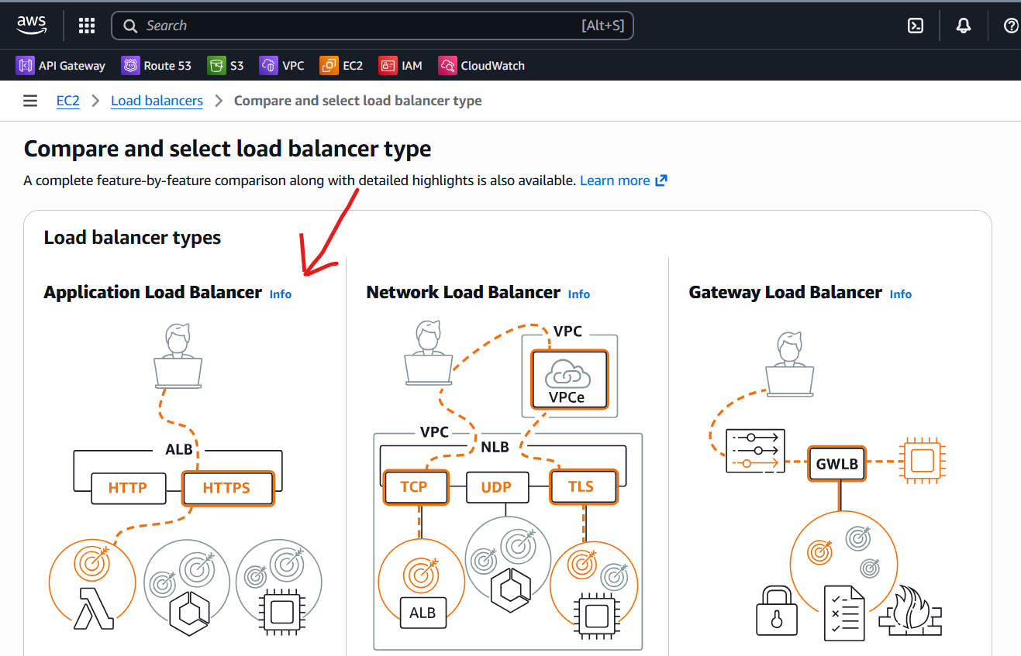
- Application load balancer is created successfully
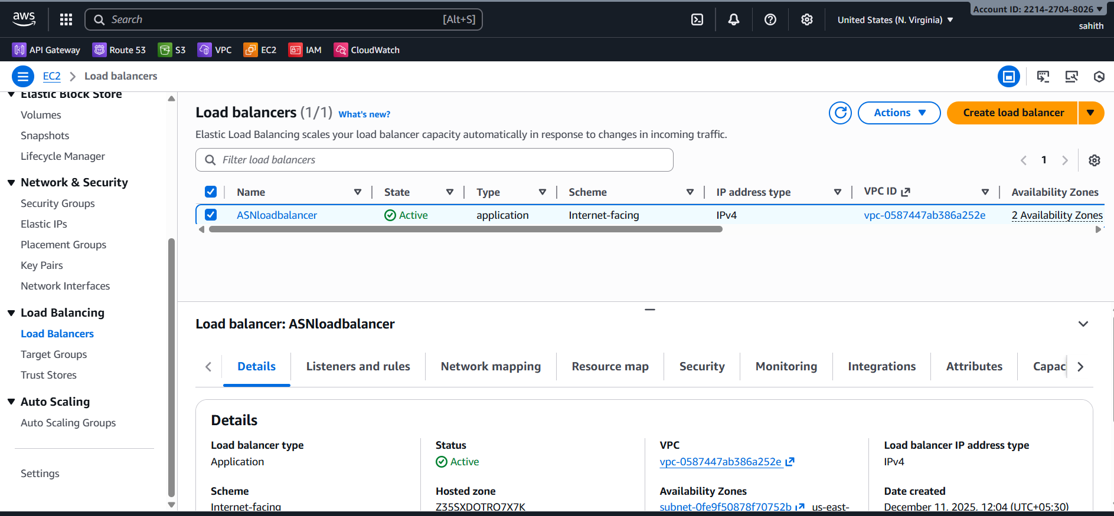
- Creating a target group to which I need to attach load balancer
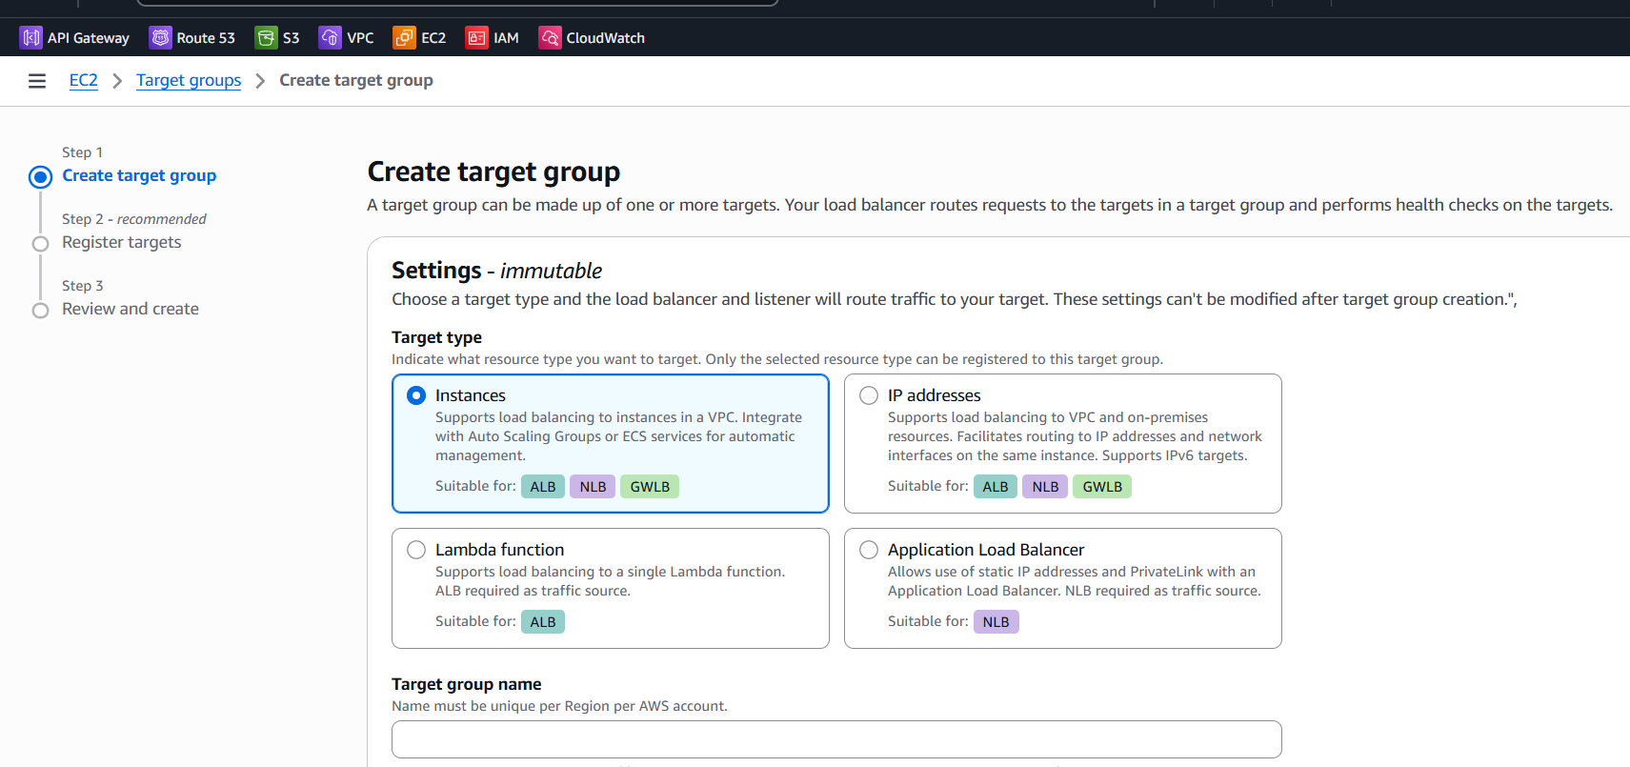
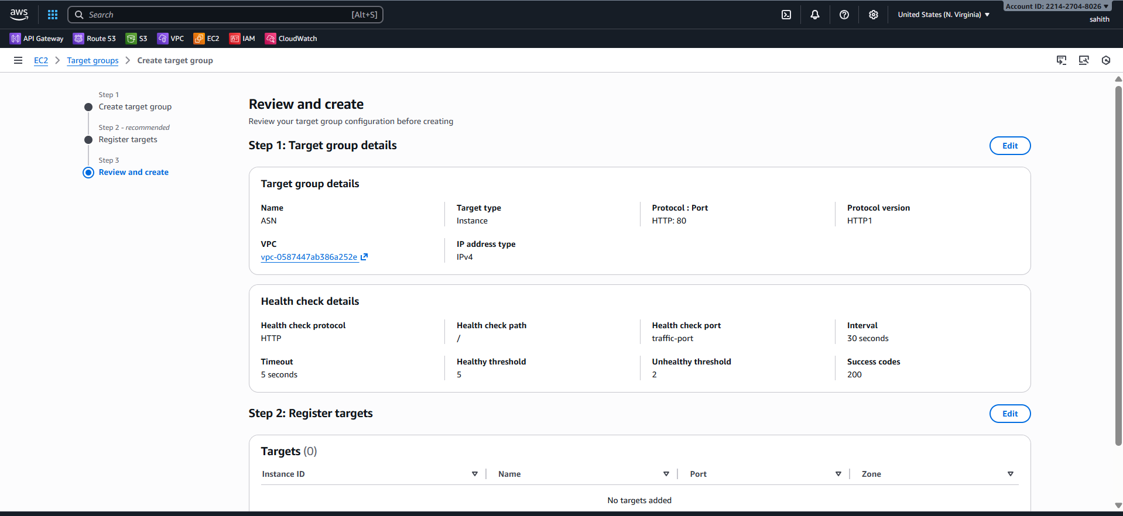
- As we can see I have attached two instances to target groups and both are running successfully
- We will know it in health status if shows healthy it is running or it will show error
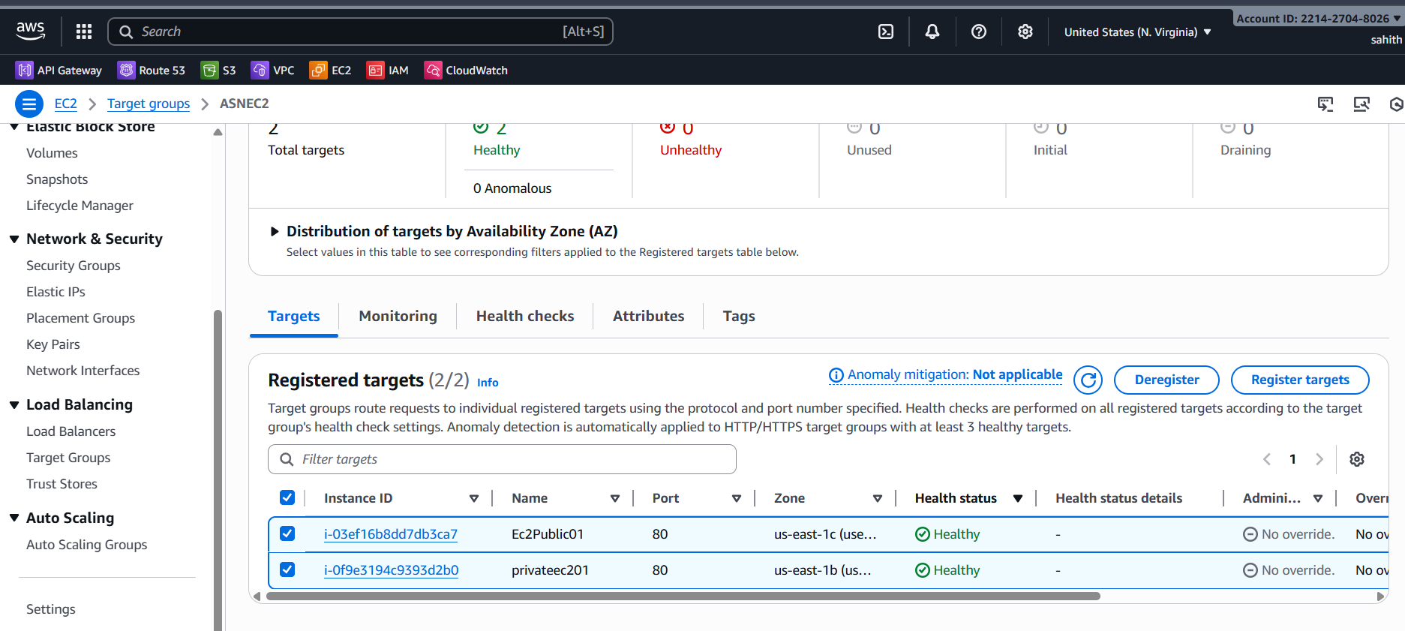
- Now redirect to load balancer > details > copy ASN load balancer from down below
- Using that URL go to browser and run it.
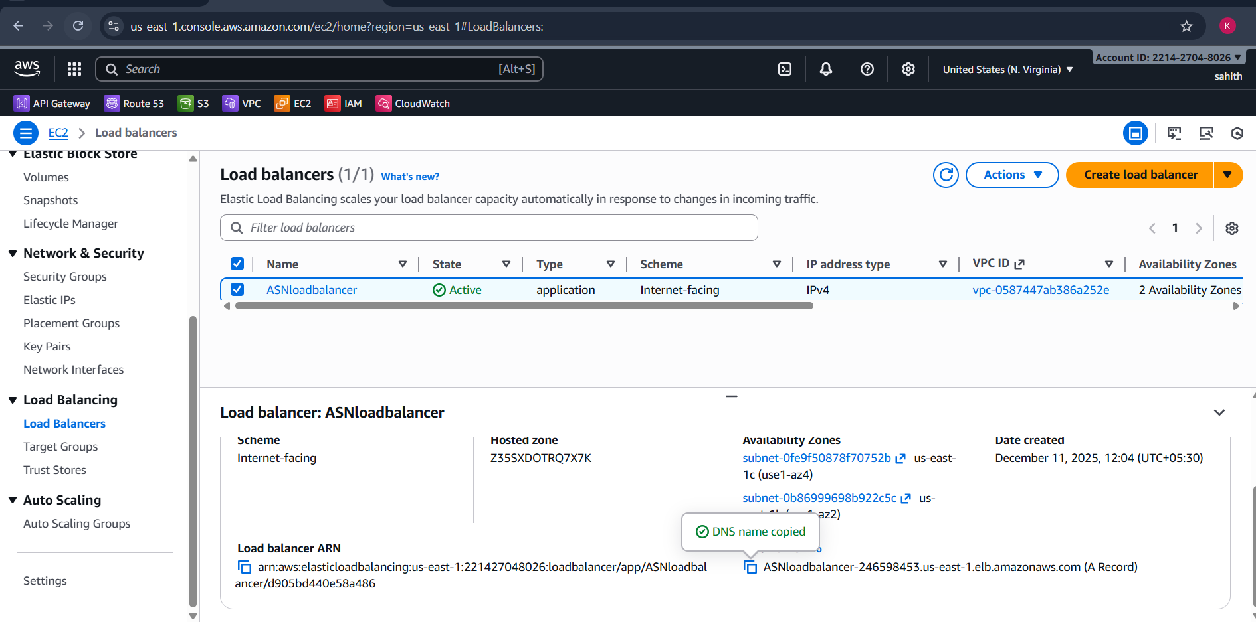
- As we can see it showing private ec2 index.html if we refresh page after few seconds it will show publicec2 index.html file.


Issues Faced
• If target health remains unhealthy:
- Confirm security group allows ALB health-check source (the ALB uses its own IPs — best to allow 0.0.0.0/0 for HTTP in test environments or the ALB SG’s ID in stricter setups).
- Ensure the web server responds on the health-check path (default /) and port (80).
- Check instance OS firewall (iptables/ufw) blocking port 80. • If ALB returns 503 or site unreachable:
- Verify target group has at least one healthy target in each AZ required.
- Confirm routing and subnets are correct (ALB subnets must be public subnets with route to IGW).
- While creating load balancer Aws account issues
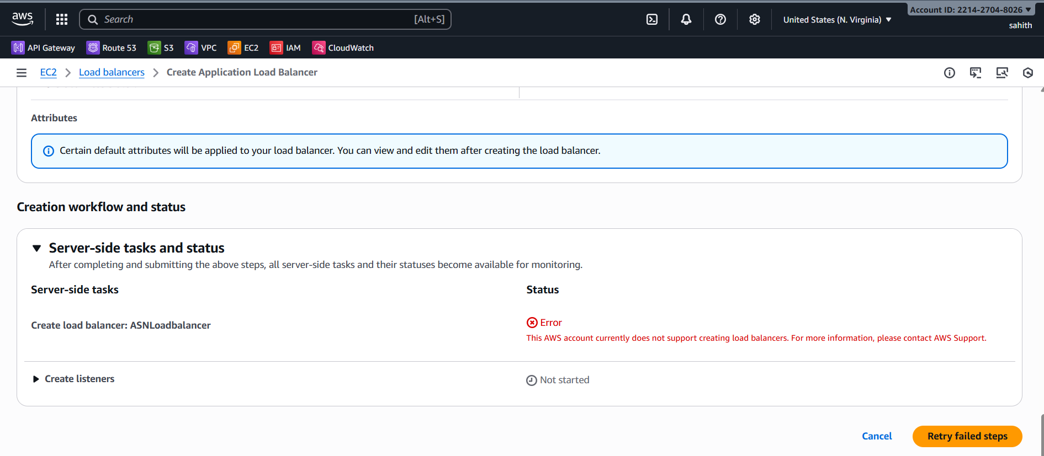
Conclusion
ALB was created and configured with a target group pointing to two EC2 instances (HTTP:80). Targets reported Healthy and application pages are reachable via the ALB DNS name. Task completed successfully as validated by ALB target health and browser verification.

- Store application load balancer logs in S3.
Store ALB Logs in S3 Bucket
Create S3 Bucket
- Name: asns3task
- Block public access: enabled
- Go to ALB → Attributes → Access Logs → Enable
- Select S3 bucket
- Save
- Step1: created an se bucket
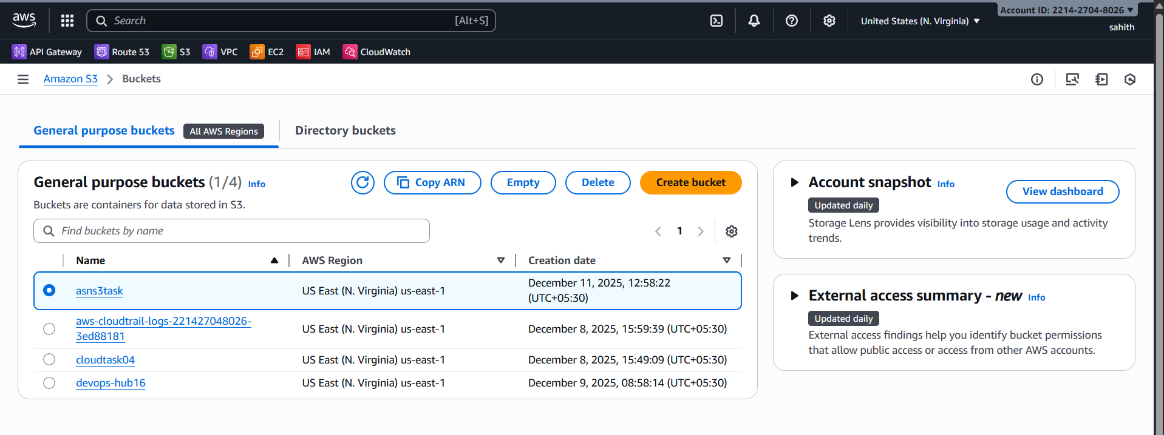
- Select the created s3 bucket > permissions > edit bucket policy > edit Json format script here by giving our aws account Id and s3 bucket name and click on save it.
{
"Version": "2012-10-17",
"Statement": [
{
"Sid": "AllowALBLogs",
"Effect": "Allow",
"Principal": {
"Service": "logdelivery.elasticloadbalancing.amazonaws.com"
},
"Action": "s3:PutObject",
"Resource": "arn:aws:s3:::asns3task/AWSLogs/221427048026/*",
"Condition": {
"StringEquals": {
"s3:x-amz-acl": "bucket-owner-full-control"
}
}
},
{
"Sid": "AllowALBLogBucketAccess",
"Effect": "Allow",
"Principal": {
"Service": "logdelivery.elasticloadbalancing.amazonaws.com"
},
"Action": "s3:GetBucketAcl",
"Resource": "arn:aws:s3:::asns3task"
}
]
}
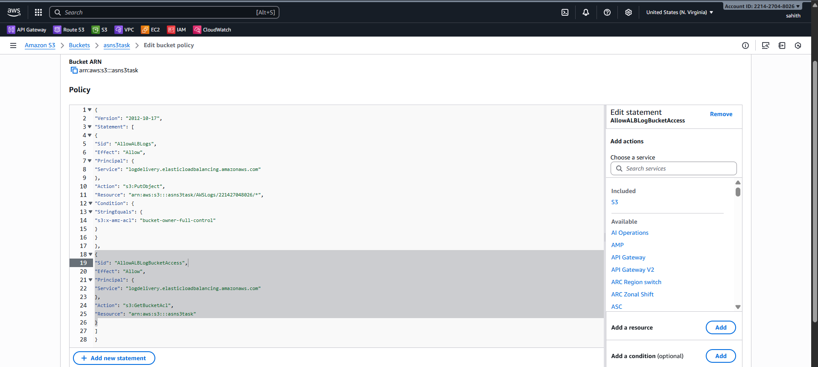
- Now redirect to load balancer > select created load balancer > click on edit attributes
- In monitoring > click on access logs > using browser s3 select s3 bucket that we created for logs in before step > click on create.
- Successfully attached s3 bucket to load balancer to store logs
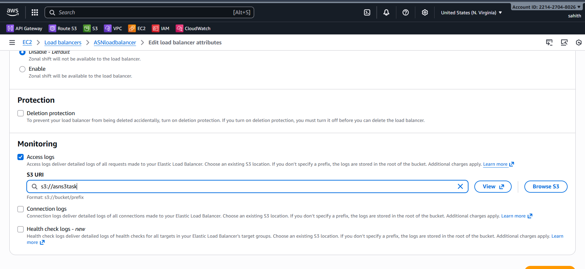
- Successfully attached s3 bucket to load balancer to store logs
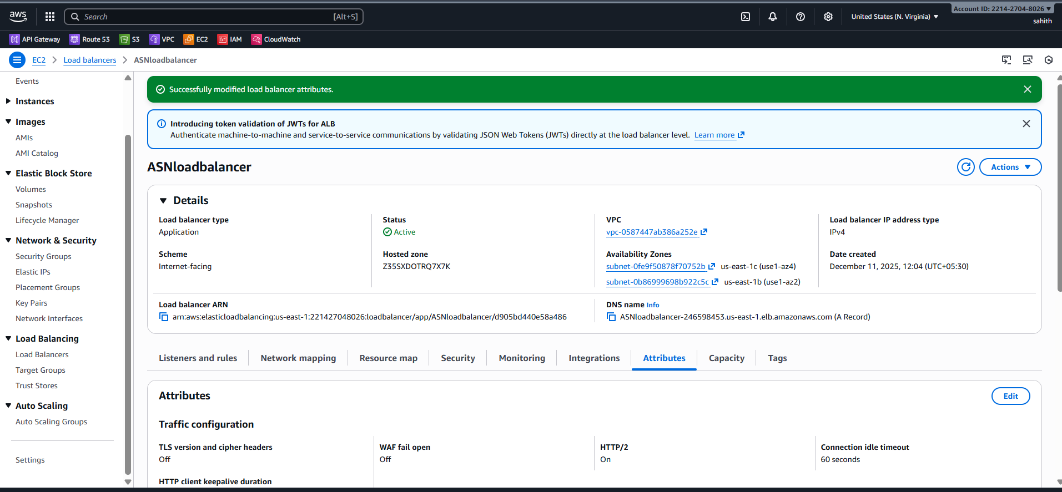
- As we see in below that logs in s3 bucket
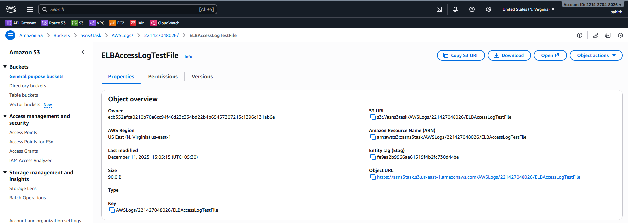
Conclusion:
ALB logging is functioning, ensuring traceability and audit capability.

- Store the VPC flow logs in a CloudWatch log group.
Enable VPC Flow Logs to CloudWatch
🔹 Objective
Capture VPC traffic logs for monitoring/security.
🔹 Steps Performed
- VPC → Flow Logs → Create
- Filter: ALL
- Destination: CloudWatch Logs
- Log group: /vpc/flow-logs
- First create cloudwatch > log management > create

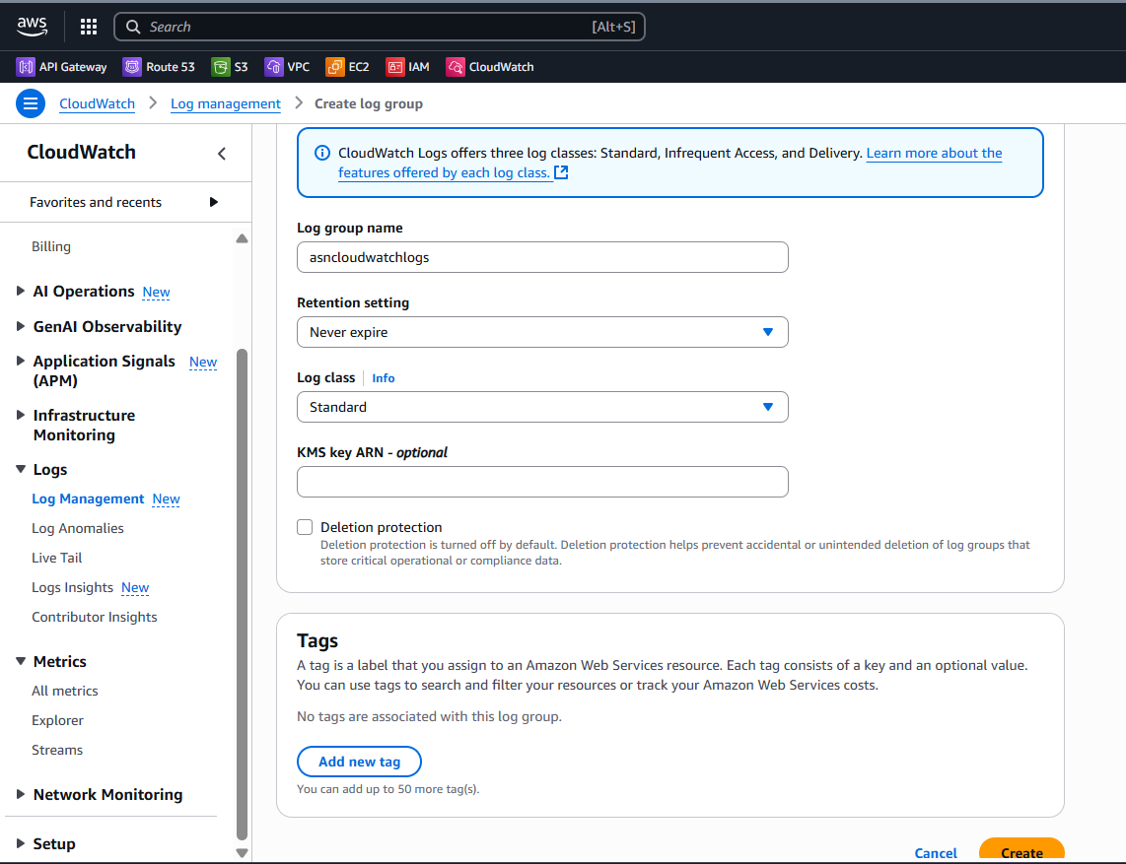
- As we can see log group has been created successfully
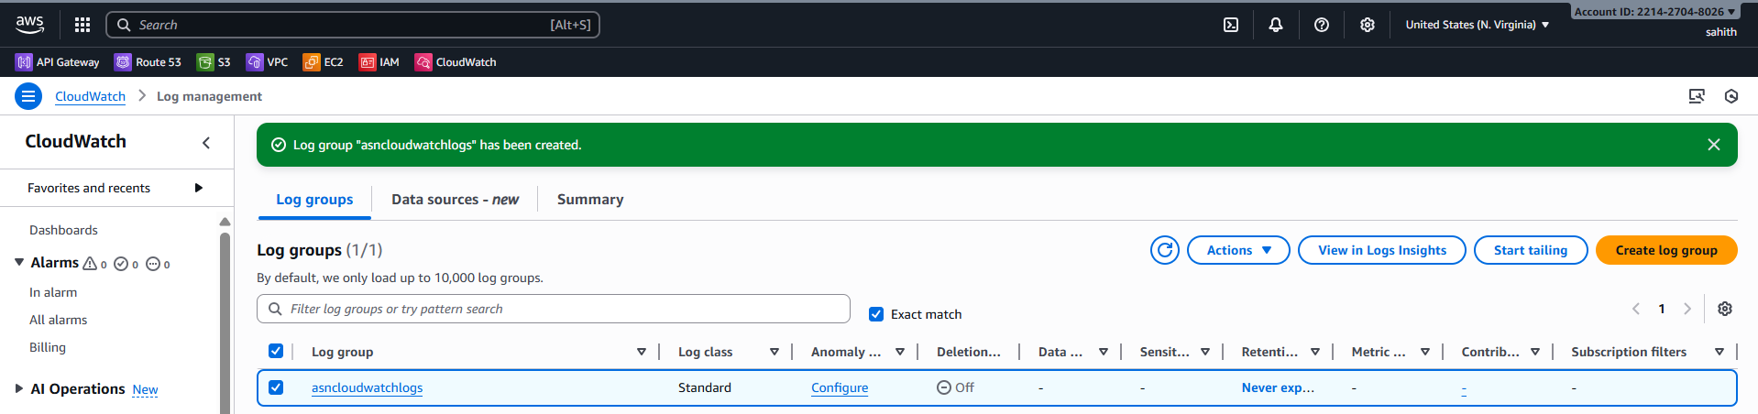
- Create vpc flow logs > filter: All > maximum: 1mintue > send to cloud watch > destination: cloud watch > create

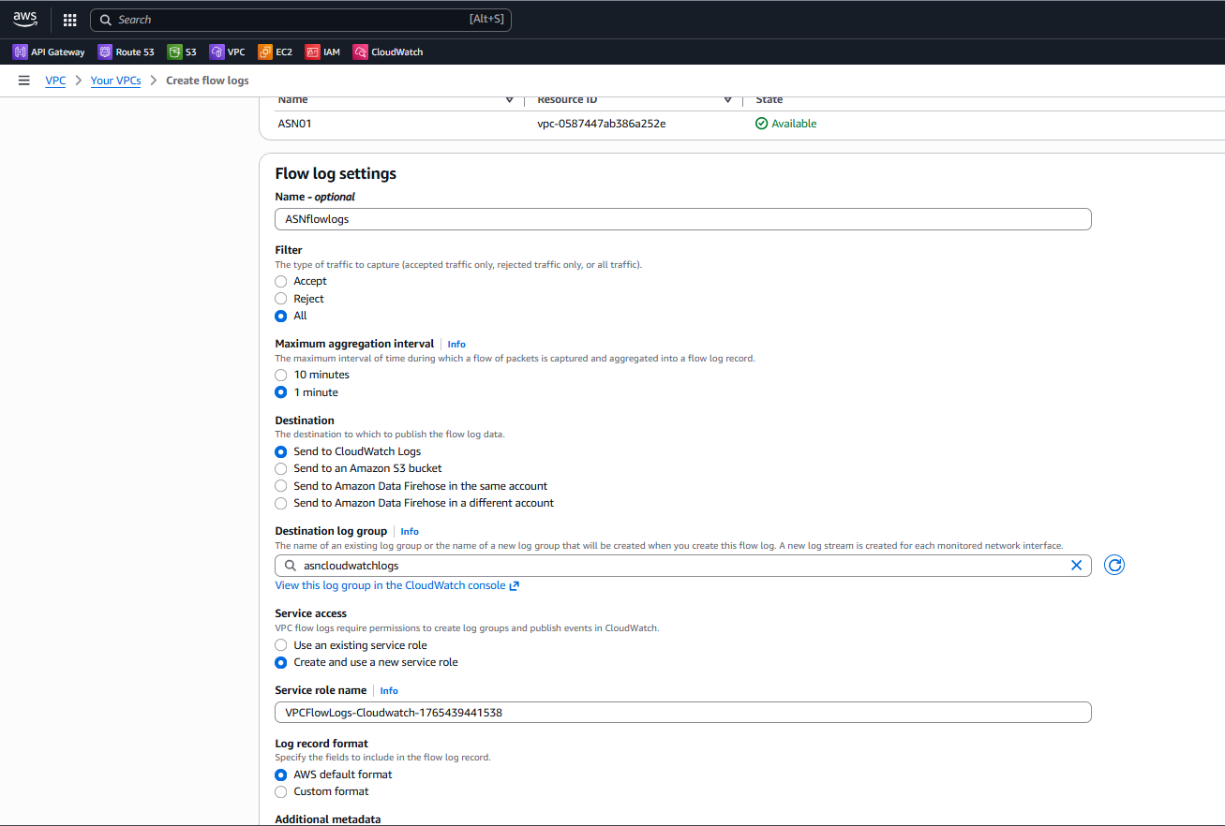
- Vpc flow logs has been created successfully
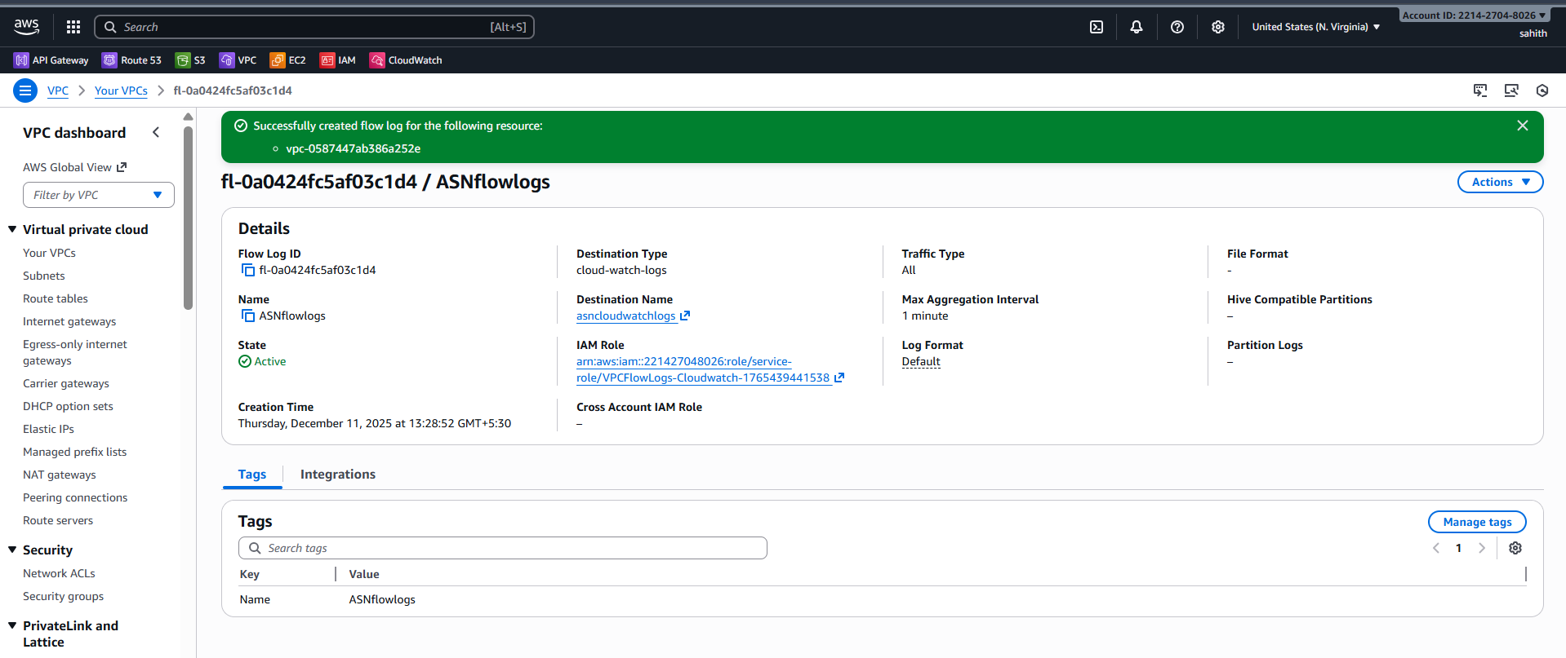
Validation:
- Go to cloud watch > logs management > click logs
- We can see logs in below screenshot
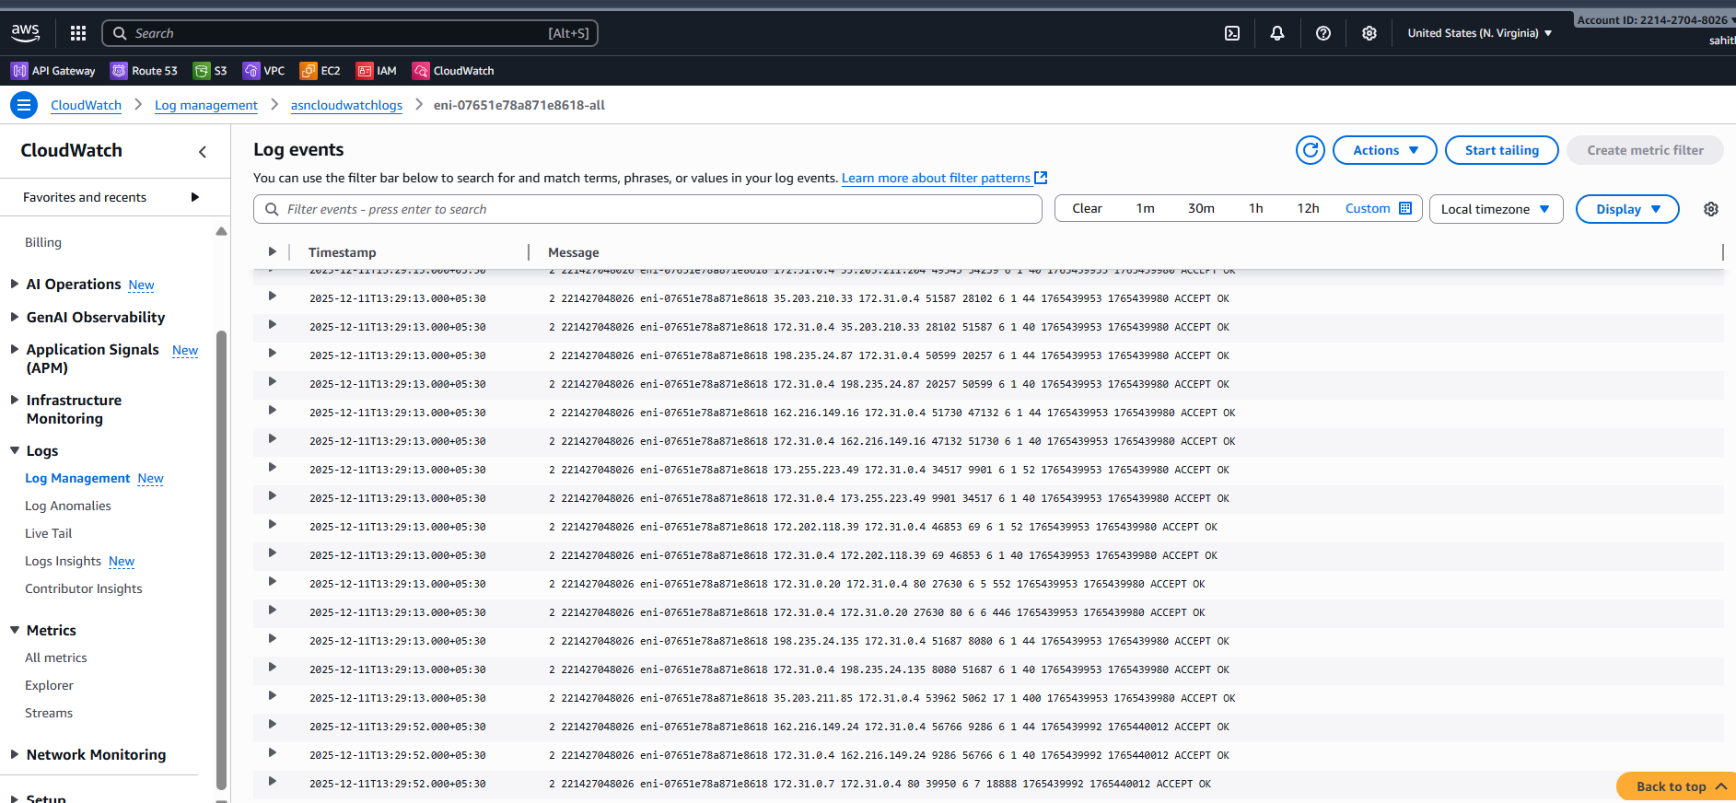
Objective:
To enable VPC Flow Logs for capturing detailed network traffic information at the VPC level and store these logs in a CloudWatch Log Group. This helps in monitoring, troubleshooting connectivity issues, analysing traffic patterns, and enhancing network security visibility.

- Create monitoring dashboards to monitor CPU utilization and to monitor the Apache service.
Objective
Monitor CPU and Apache service health.
🔹 Steps Performed
- Go to Dashboards → Create Dashboard
- Add CPU widget
- Install CloudWatch agent
- Add Apache log/service monitoring

- Script:
#!/bin/bash
REGION="us-east-1"
NAMESPACE="ApacheService"
METRIC_NAME="httpd_status"
SERVICE_NAME="httpd"
AWS_CLI="/usr/bin/aws"# Fetch Instance ID (IMDSv2)
TOKEN=$(curl -s -X PUT "http://169.254.169.254/latest/api/token" \
-H "X-aws-ec2-metadata-token-ttl-seconds: 21600")INSTANCE_ID=$(curl -s -H "X-aws-ec2-metadata-token: $TOKEN" \
http://169.254.169.254/latest/meta-data/instance-id)# Check Apache Status
if systemctl is-active --quiet "$SERVICE_NAME"; then
STATUS=1
else
STATUS=0
systemctl start httpd
fi# Push Metric to CloudWatch
$AWS_CLI cloudwatch put-metric-data \
--region "$REGION" \
--namespace "$NAMESPACE" \
--metric-name "$METRIC_NAME" \
--value "$STATUS" \
--dimensions Name=InstanceId,Value="$INSTANCE_ID"
- As we already installed and running the httpd
- Now, using vi apachemonitor.sh enter above script in it and save it
- Gave permissions to file and executed it. But, it through an error saying aws login.
- Using access key and secret key logon to aws and now I executed here
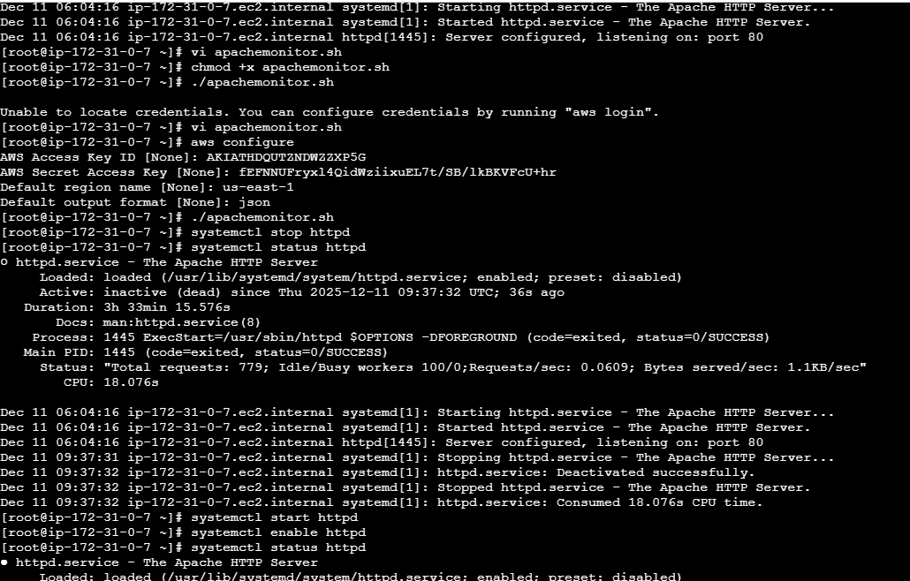
- Installed cronjobs here to trigger alert
- Start, enable and status cronjob
- Using command: crontab -e: insert this in vi “* * * * * apachemonitor.sh >> /tmp/httpd.log 2>&1”
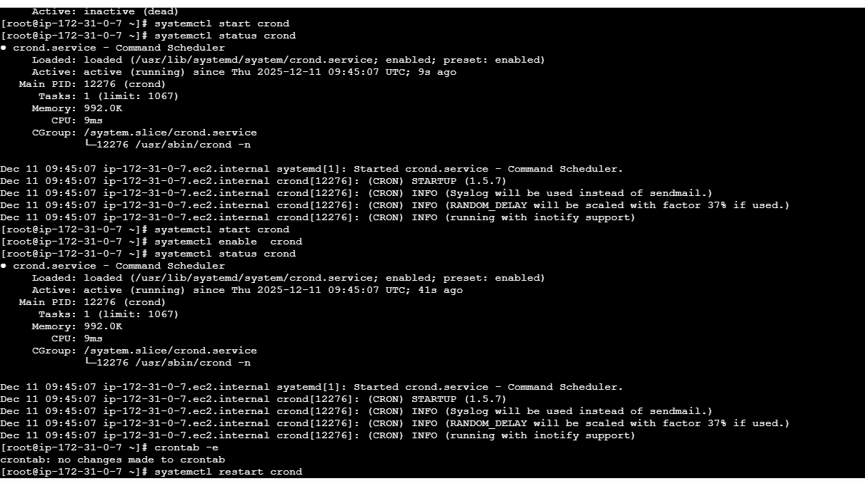
- Created an dashboard for both httpd status and ec2 CPU utilization

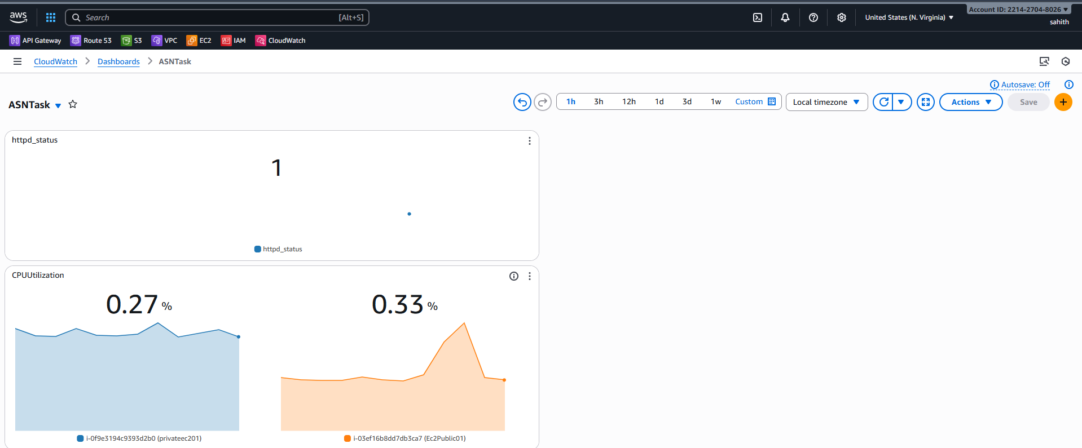
- Created an alarm for httpd if fails to run and one alarm for CPU utilization if it exceeds threshold.
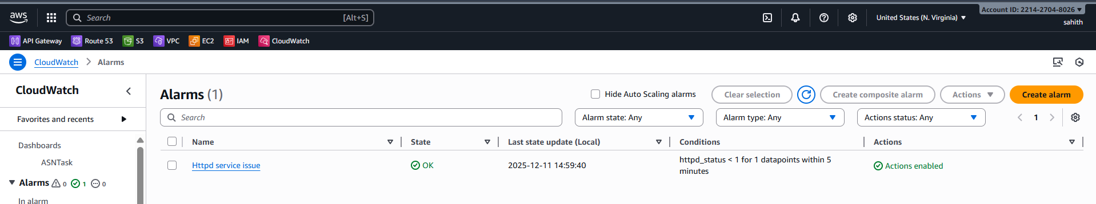
Conclusion:
The CloudWatch dashboard was successfully created and now provides real-time visibility into EC2 CPU utilization and the Apache service status. With these widgets, system performance and web server health can be monitored continuously, enabling faster detection of issues and improved operational efficiency. The dashboard is fully functional and displays accurate metrics from both EC2 instances.

- If CPU utilization is more than 70%, then it should trigger auto scaling and launch new instance.
Auto Scaling When CPU > 70%
🔹 Objective
Automatically launch new EC2 instances when CPU is high.

Create Launch Template
Create Auto Scaling Group (ASG)
Steps
- Create ASG
- Attach Launch Template
- Attach ALB Target Group
- Scaling Policy:
  - CPU > 70% → Add capacity
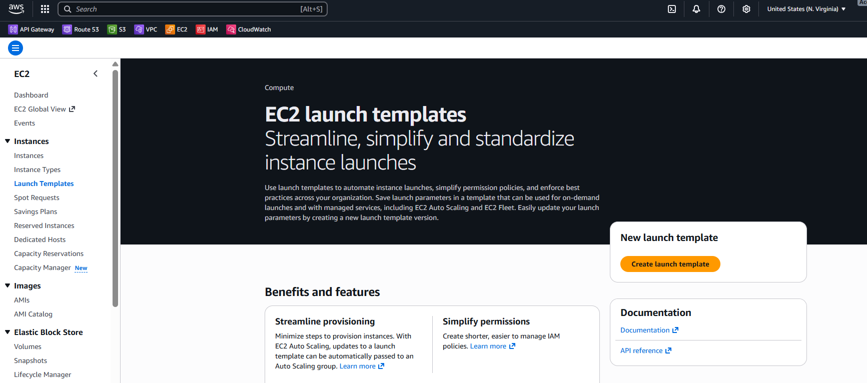
- Created new launch template
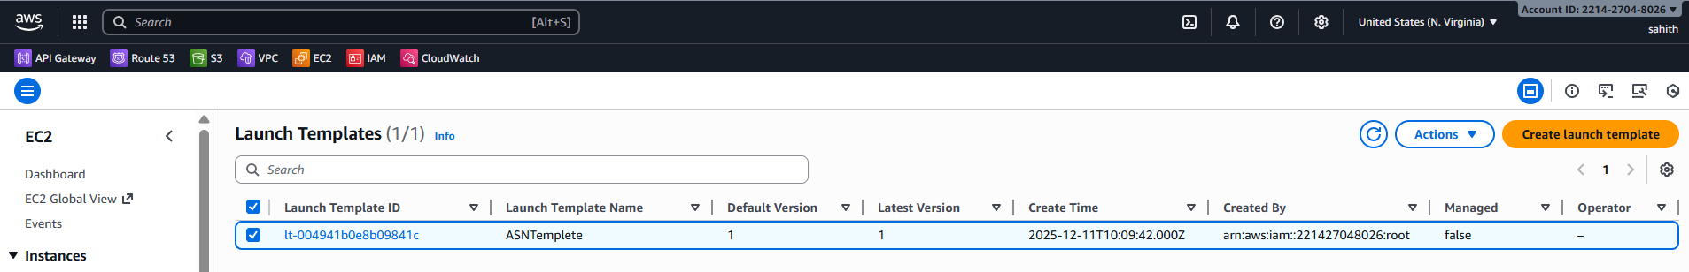
- Now, creating Auto scaling group
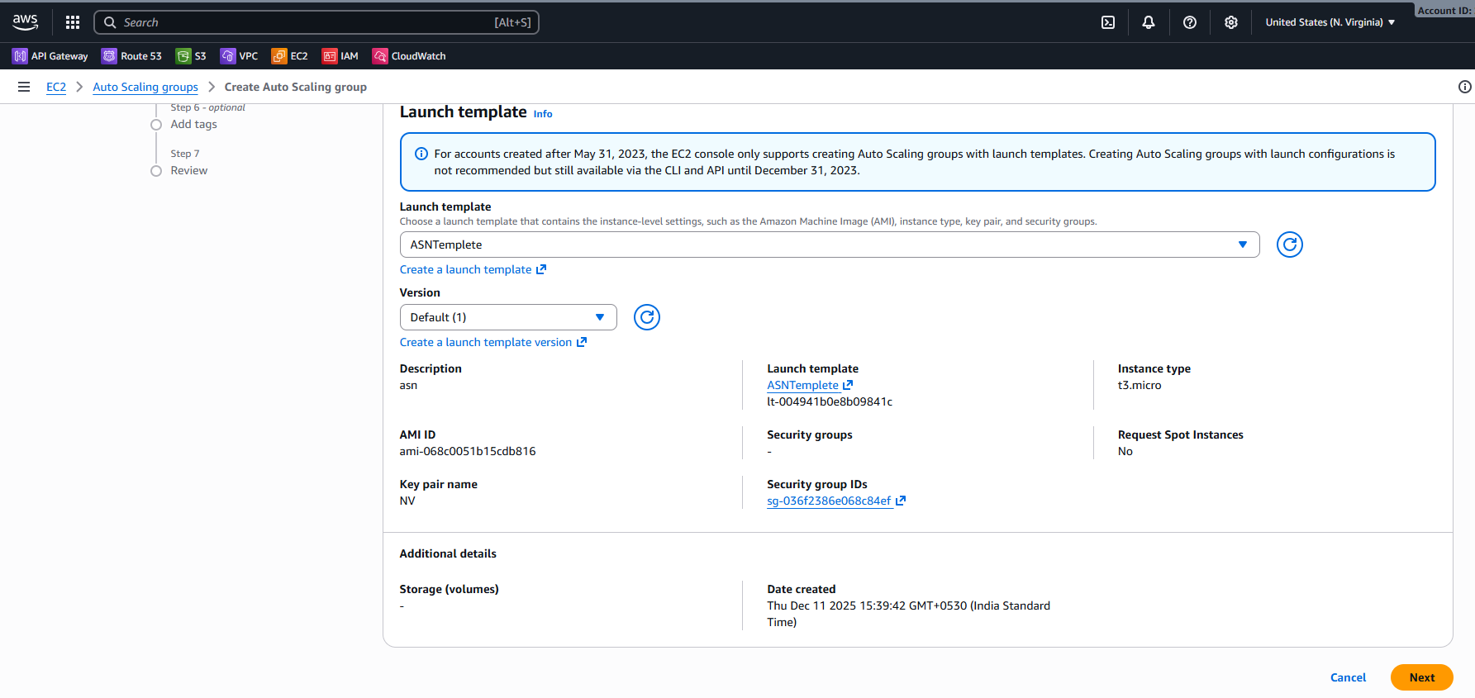
- Select vpc and availability zones and subnets > availability zone distribution: balanced best effort
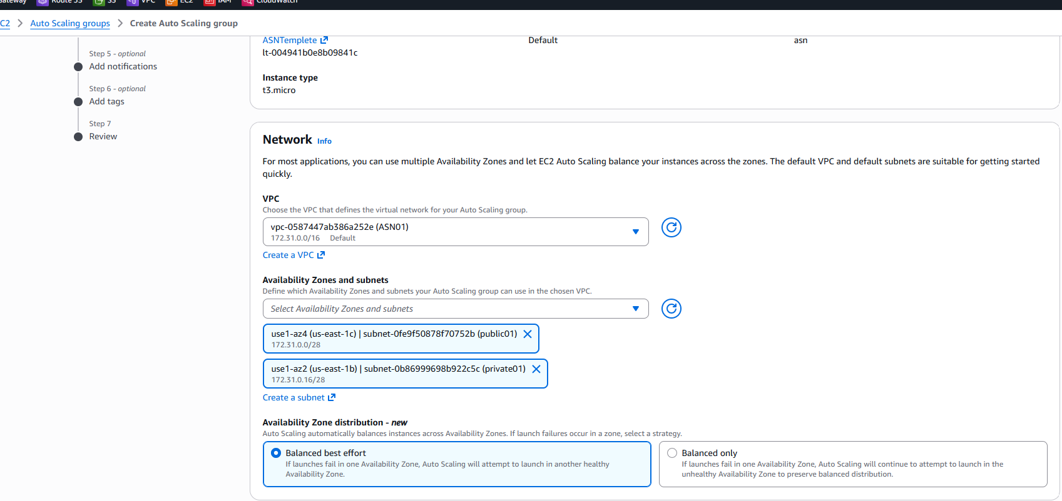
select
- minimum: 1
- Desired: 2
- Maximum: 5
- Automatic scaling: target tracking scaling policy > Target value: 70 > warmup: 60 seconds
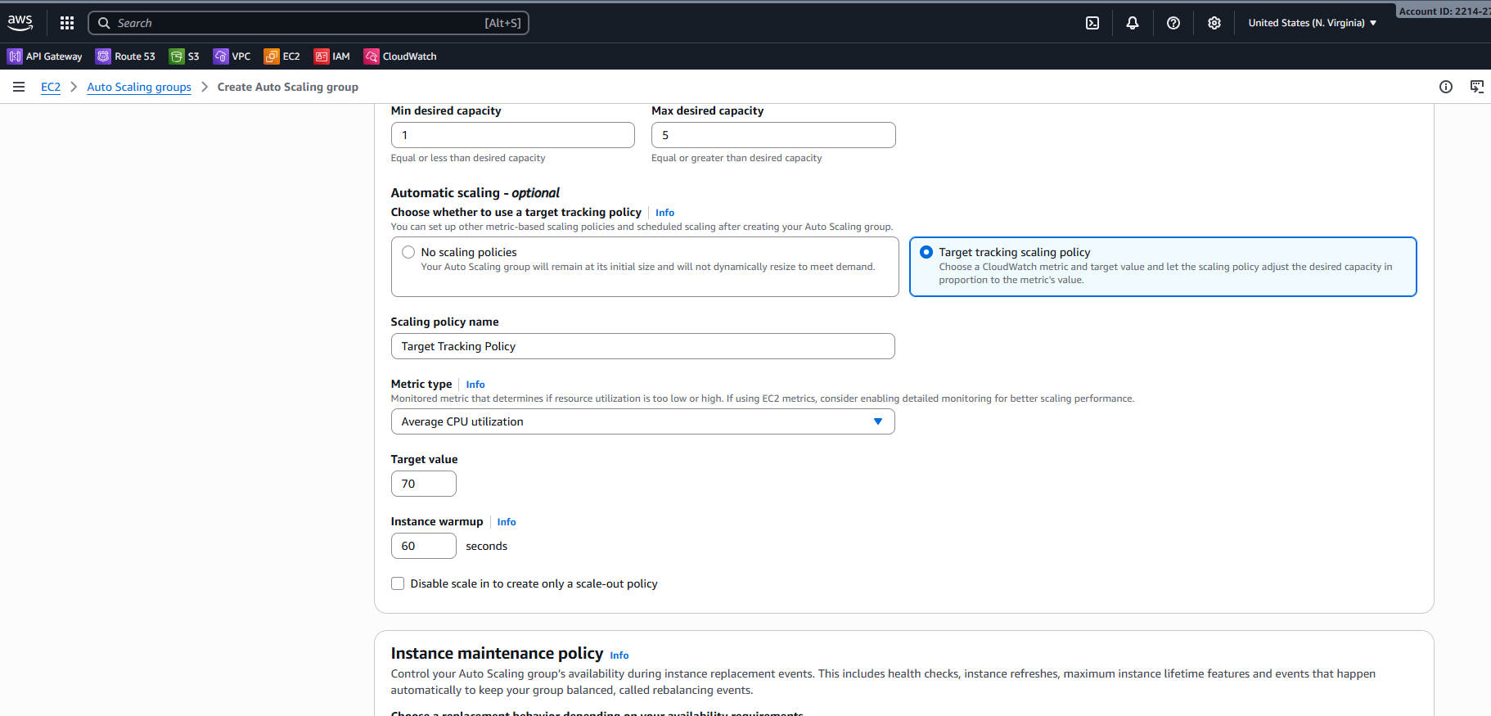
- Auto scaling has been created successfully and attached
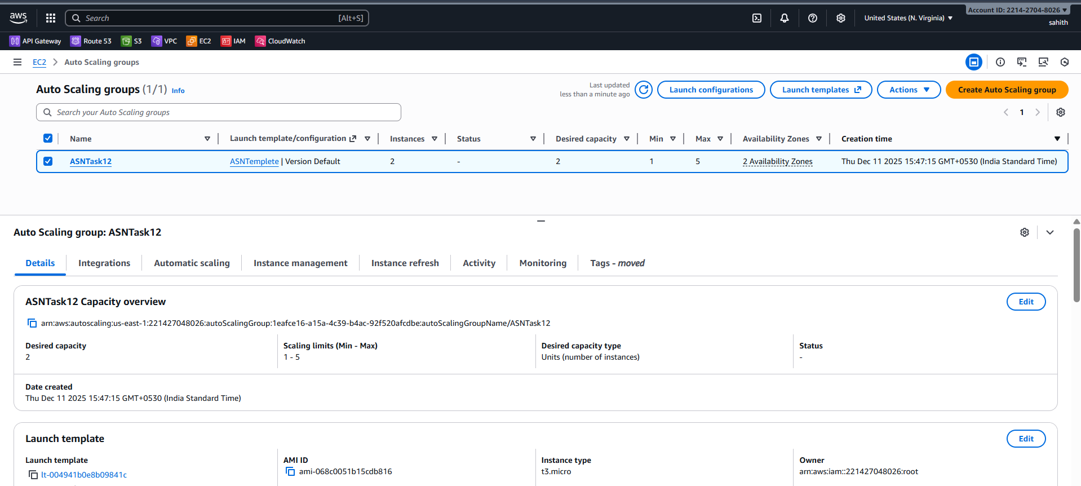
- Validation:
- As we can first, I had two ec2 instances as I increased load on CPU it created few new instances as we can below.
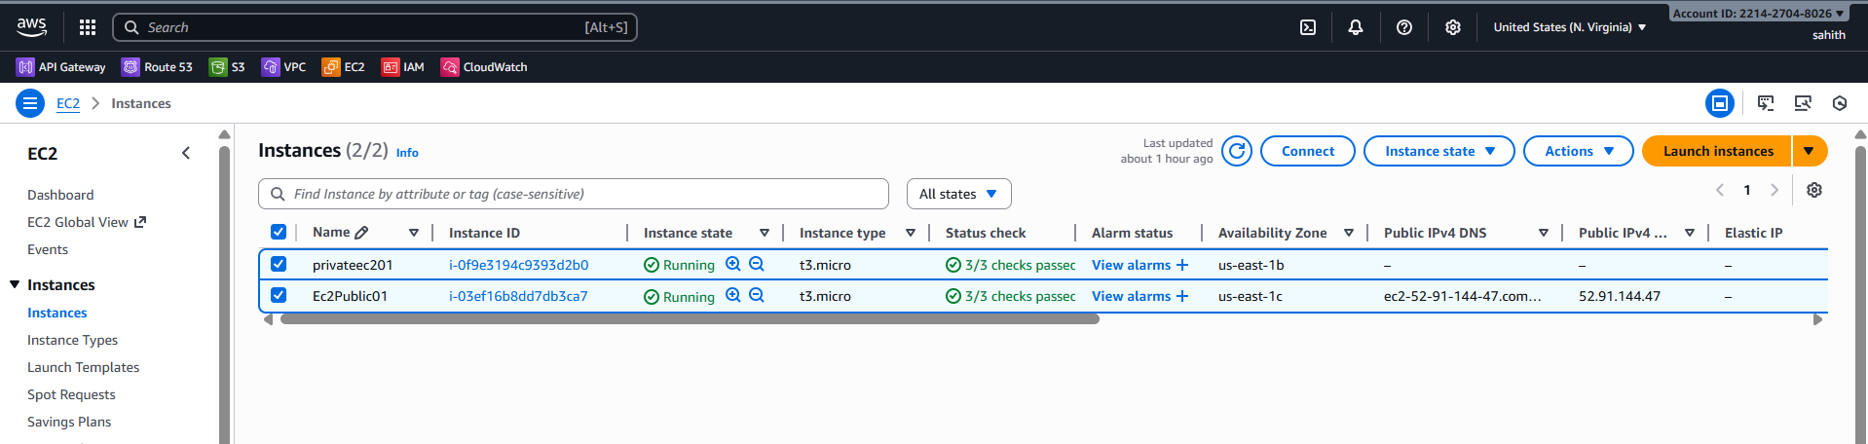
- Created fake load on CPU
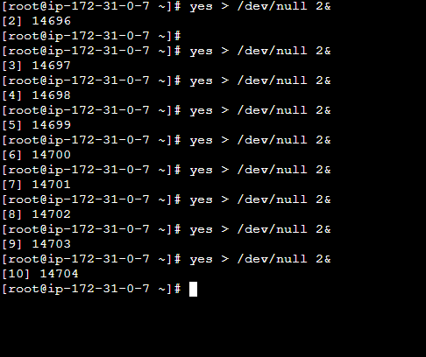
- As we can see below ASG is creating new instances
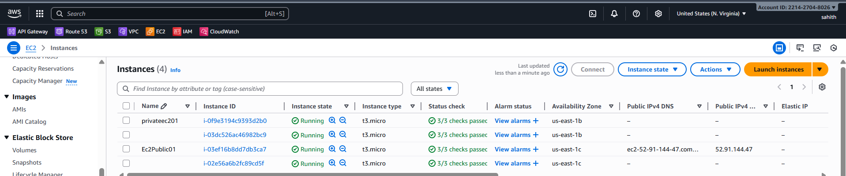
Conclusion:
The Auto Scaling Group (ASG) was successfully configured with a CPU-based scaling policy that triggers when utilization exceeds 70%. When the threshold is reached, new EC2 instances are automatically launched using the defined launch template, ensuring increased application capacity and maintaining performance during high workloads. This setup enables seamless scalability, high availability, and improved fault tolerance for the application environment.

